**Functional Specification- Production order confirmation CO11N Validation**

**Step-1)** Order confirmation trying without Header Material, System should not allow confirmation & Give Error message.

**Test data- Production order 120005423**

**Step- 1.1) Operation 10 Confirmation-** Operation 10 should allow, as in this there is **no Header** material.

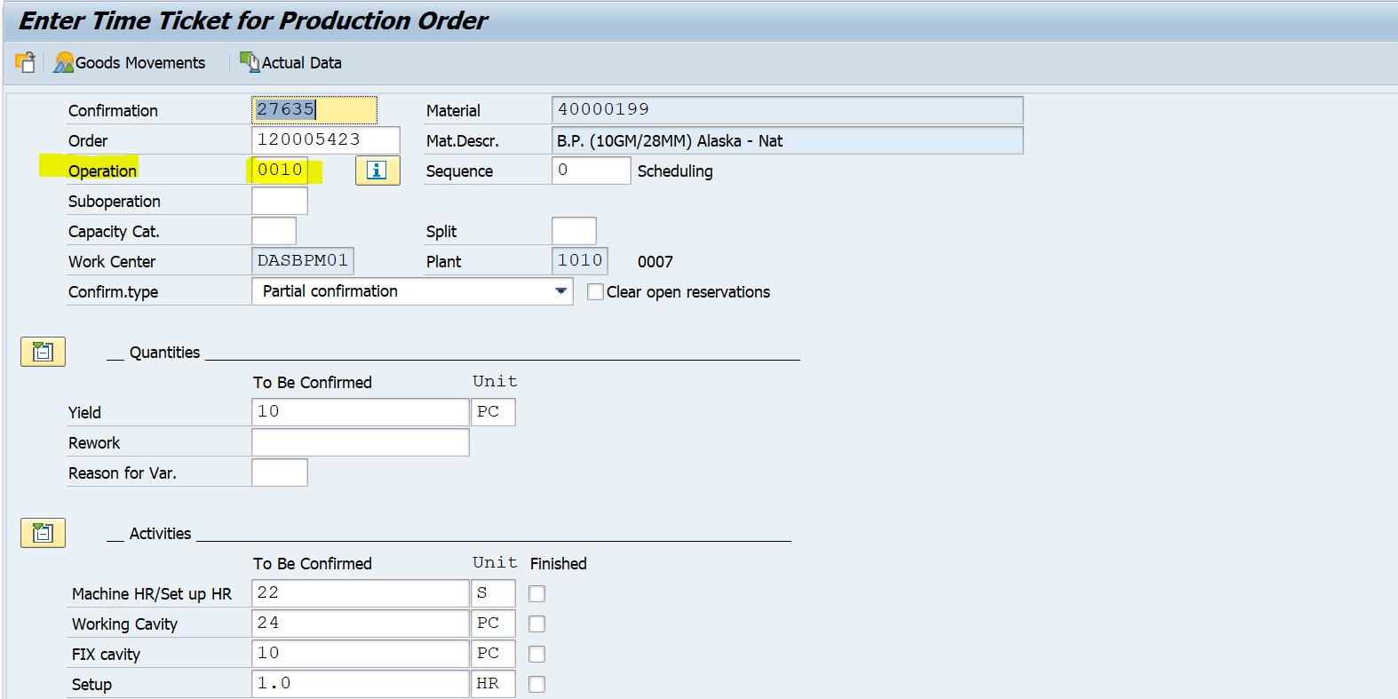

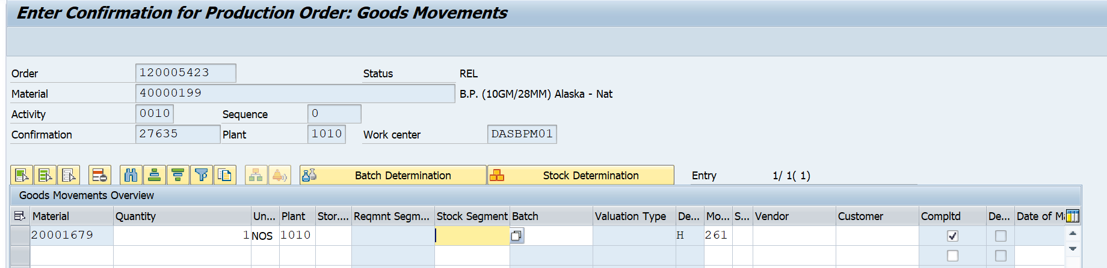



**Step- 1.2) Operation 20 Confirmation- Should allow only if having Header material (101) In Goods movement**

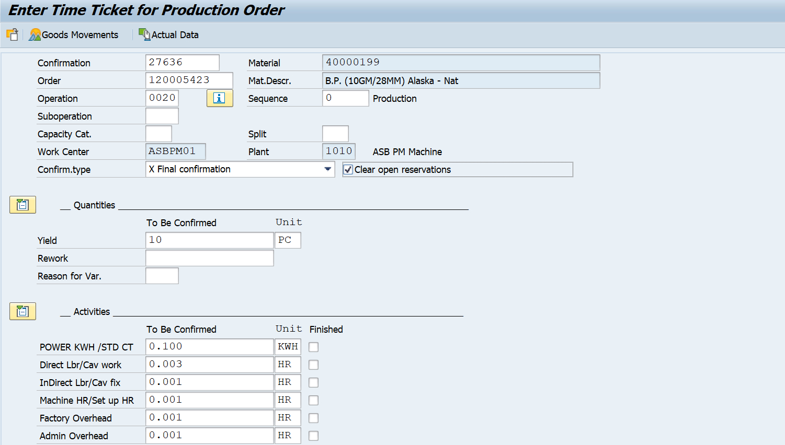

Deleting Header material 40000199 i.e. 101 Movement in Goods movement

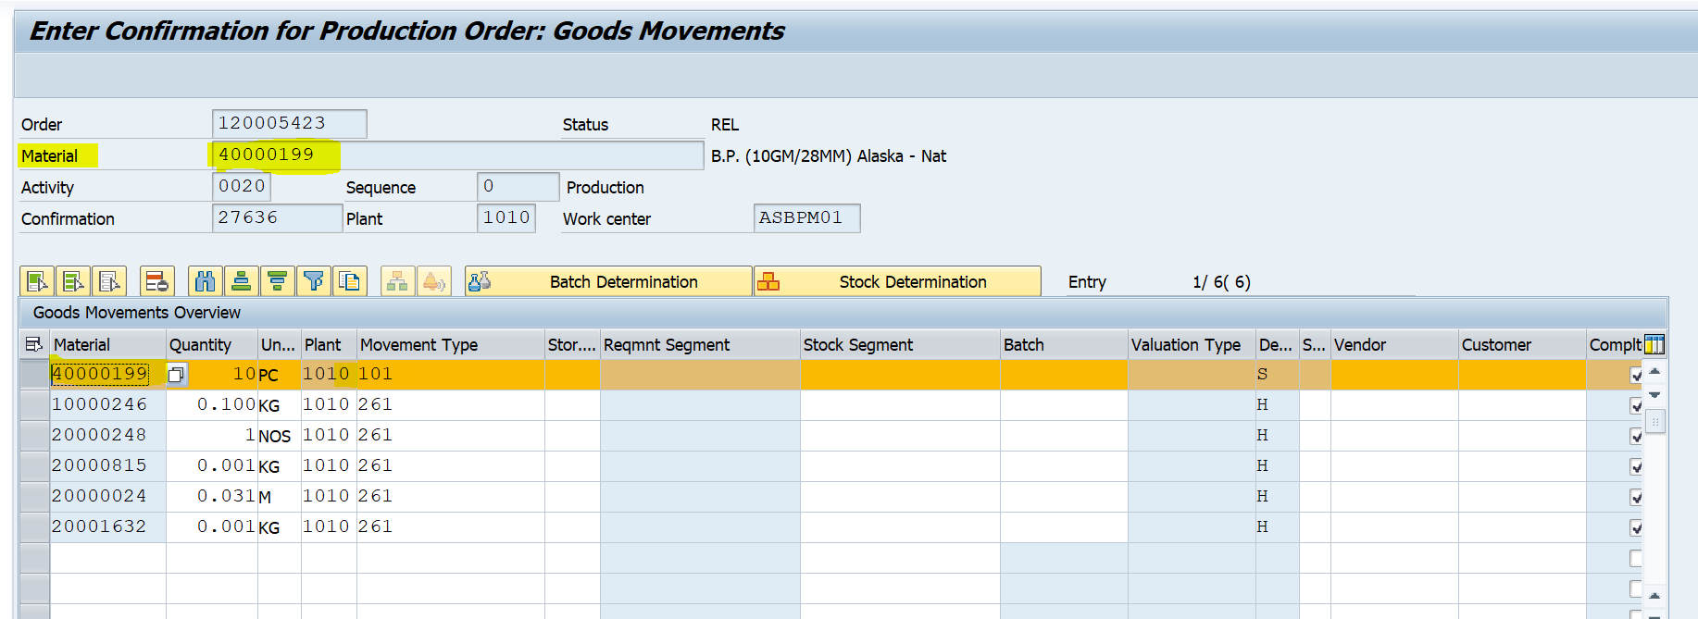

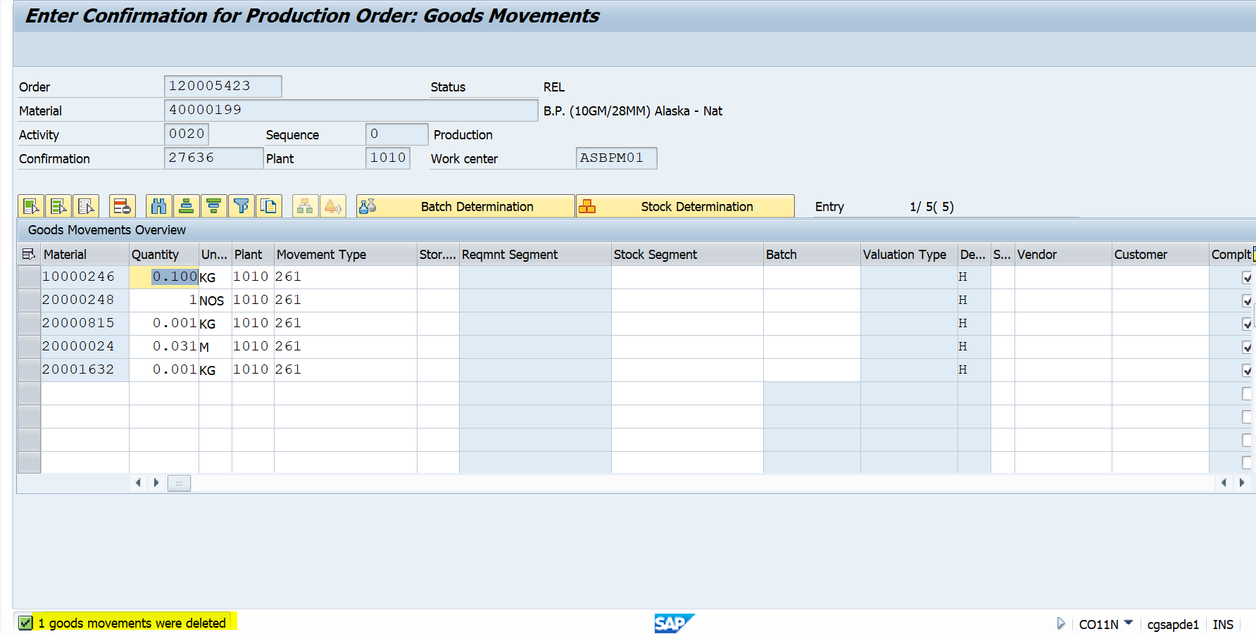

Now if trying to save, system should not allow to save & give error Message like

**“Header Material missing for Goods Receipt 101”.**

**BADI**

workorder_confirm

OR

**User Exit**

CONFPP05 PP order conf.: Customer specific enhancements when saving